ATIC Accessibility
To support the accessible community in making informed travel decisions for their individual needs

This report prepared for:
Business name: | Geraldton Visitor Centre
Address: | 24 Chapman Road
Town: | Geraldton
Date: | 2024-05-16 15:39

ATIC Accessibility
The following pages provides travellers with information on the businesses facilities and amenities which aims to support the traveller to make an informed decision on whether the business is suitable for their individual needs.
OVERVIEW 3
Business Overview 3
Bookings 3
Emergency Management 3
Communications 4
Other Information 4
GENERAL 5
Pre-arrival, arrival and reception 5
Car Park and Access amenities 5
Entry 5
Lifts 6
Internal Spaces 6
Public areas 6
Displays, exhibits, commentary and live performances 6
External Paths 6
Public Toilets/Adult change facilities 7
ATTRACTIONS 8
Attractions Basics 8
COMMON AREAS 10
Parks and gardens 10
Report Disclaimer 12

OVERVIEW

Business Overview

The business has the following products/services available
- Attraction

Our business caters for the following disability types:
- Limited mobility
- Wheelchairs or mobility scooters

Bookings

The business offers the following methods for bookings and enquiries:
- Phone
- Email
- Webportal
- Our website supports Screen Readers
- Our forms have high contract boxes and submit boxes

Emergency Management
we are a Visitor centre and have the evacuation procedure on the wall
- There are Audible device/s to alert occupants to evacuate with instructions on how to evacuate.
- Exit signs are clear and easy to see
- Exit access is free and clear at all times
We ensure exit access is free and clear at all times by: we do checks to make sure nothing is blocking the emergency exits
- Exits and access to exists are greater than 900mm
- Exit doors are able to be opened by all occupants
- The evacuation point is clearly marked by a sign
The business identifies guests who need additional assistance should an emergency occur by: We have fire wardens trained in evacuation
The procedure for assisting guests who need assisted rescue is: We have a dedicated fire warden team and a first aid officer who have all completed their training

Communications
- Our website meets WCAG 2.0 accessibility standards
- Our business offers the following alternative communication methods
- Plain English
- There is easy to read signage and information (e.g. menus and emergency information)
we have a touchscreen available

Other Information
- For bookings made onsite, the ticket booth/counter/box office is accessible for people using a wheelchair
The business provides the following services for services animals: they can bring the service animal into the centre

GENERAL

Pre-arrival, arrival and reception
The business has the following in place to support guests during pre-arrival, arrival and reception
- Booking information and websites are compatible with screen readers
- There is a reception/public entryway.
- A lower counter at reception/ticket office
- A tablet with text to voice or pen and paper at reception to aid in communication
- Lighting in the reception area is even and glare free
we don't have a check in system
- Information and maps are available in written form
The following steps are in place to ensure that people with fatigue related to their disability are not disadvantaged by long wait times: we have a fast turnover and other staff that could help out in busy periods

Car Park and Access amenities
The business has the following Car Park and Access amenities
- Designated disabled parking bays
- Level or ramped access from the car park to the entrance
- Kerb ramps are in place where a pavement or walkway needs to be crossed

Entry
The business has the following amenities/systems in place for entry
- A path of access to the building is slip resistance and even
- A path of access to the building is clear of obstruction
- Self opening entry doors or fitted with a self closer
- Door jams/doors are of a contrasting colour to surrounding walls
- Door handles are of a contrasting colour to the door
- Signage is written in a contrasting colour
- Signage is written in a Sans Serif font and use upper and lower case letters
- The entry door is a minimum of 850mm wide
- The entry door has self opening or a light opening pressure (for manual operations)
- The entrance sill is less than 13mm
- There a clear space of at least 1500mm x 1500mm in front of all doors.
- The entrance door mats have a thickness less than 13mm and a width of 7500mm or greater

Lifts
- The lifts have the following amenities in place

Internal Spaces
- Clear and unobstructed routes through and between buildings
- Interior walls are matte or low sheen
- Floors, walls, counters and furniture are of contrasting colours
- Any protruding or overhanging obstructions are at least 2meters above the floor or are protected
- Floor surfaces are hard or short pile carpet
- Seating is available for guests unable to stand for long periods
- All corridors greater than 900mm

Public areas
The public areas have the following amenities in place
- Even lighting
- Seating

Displays, exhibits, commentary and live performances
For displays, exhibits, commentary and live performances the following amenities are in place
- Seating
- Wheelchair accessible spaces/seating
- A written transcript where audio description is provided i.e. display commentary, tour commentary

External Paths
External paths of travel have the following amenities are in place
- Surfaces are concrete, asphalt, smooth paving or hard packed fine gravel (max aggregate size 13mm)
- Paths or slopes longer than 15 metres have resting places or seats
- Pathways are wider than 900mm

Public Toilets/Adult change facilities
Public Toilets/Adult change facilities have the following amenities are in place
- There is an accessible toilet for public use
- The door is at least 850mm wide
- There is a minimum of 850mm beside the toilet
- Handrails are fitted
- The toilet seat of a contrasting colour to the floor
- The toilet seat is460mm above the floor

ATTRACTIONS

Attractions Basics
- A park map is available here:
https://www.visitgeraldton.com.au/about/wayfinding.aspx
  - Image(s)
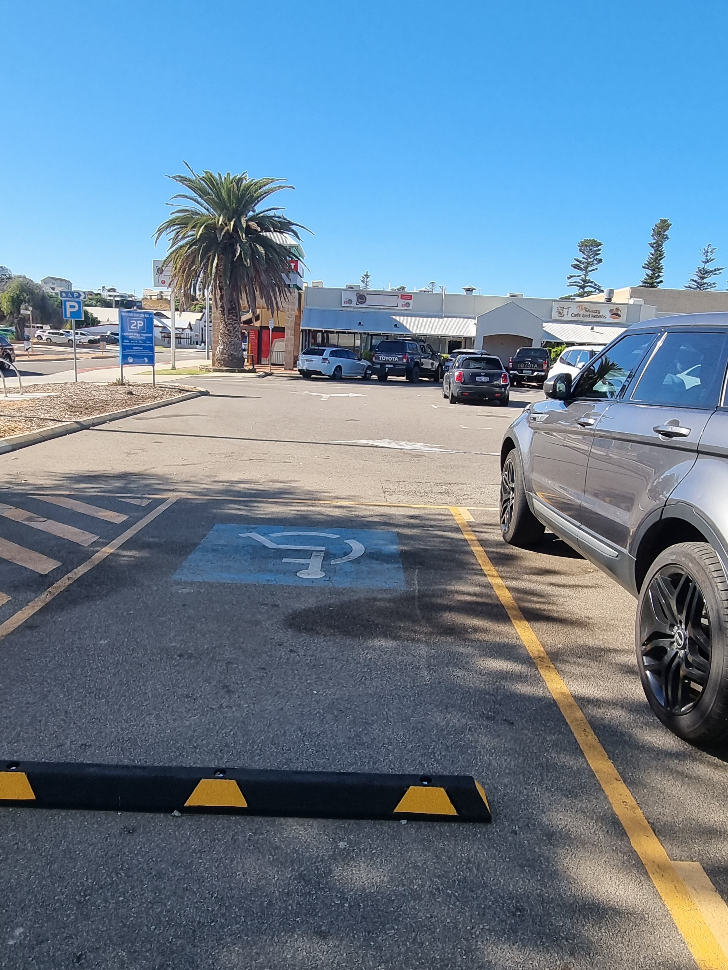
Disabled parking
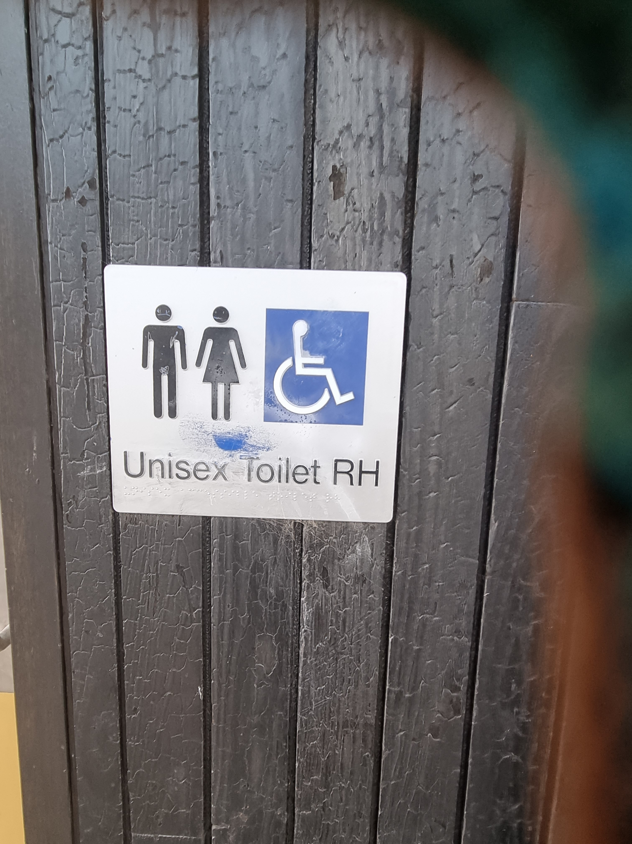
disabled toilet signage
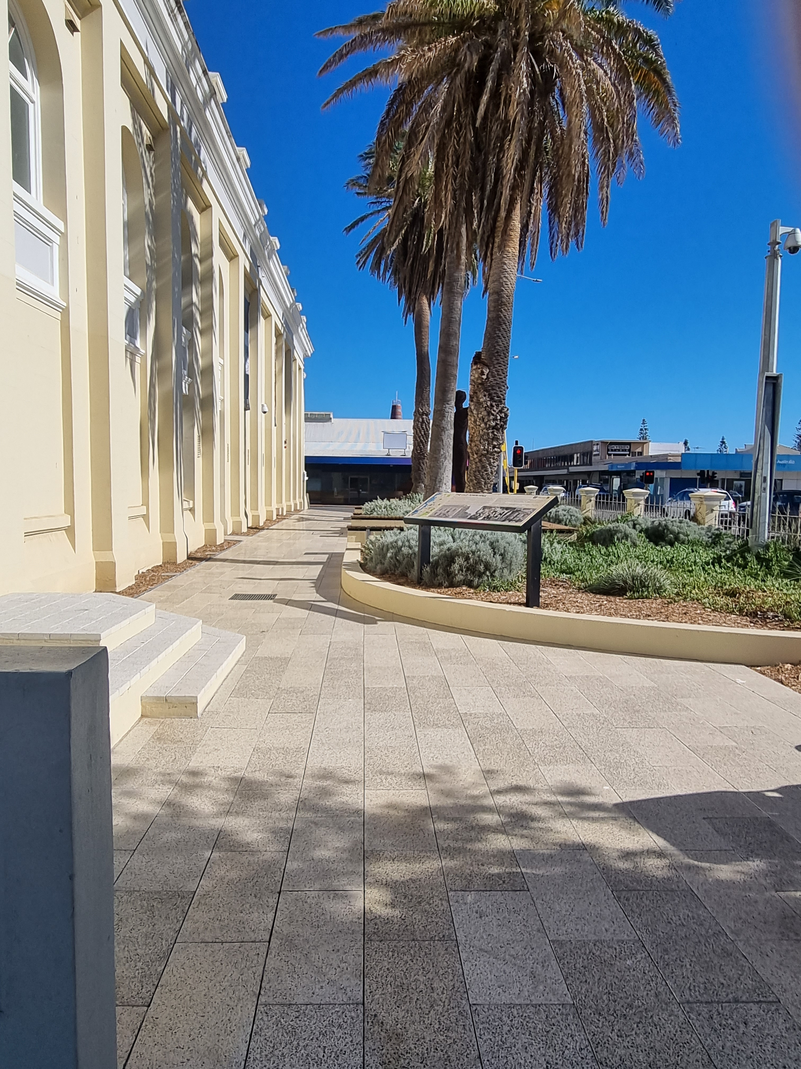
side entance
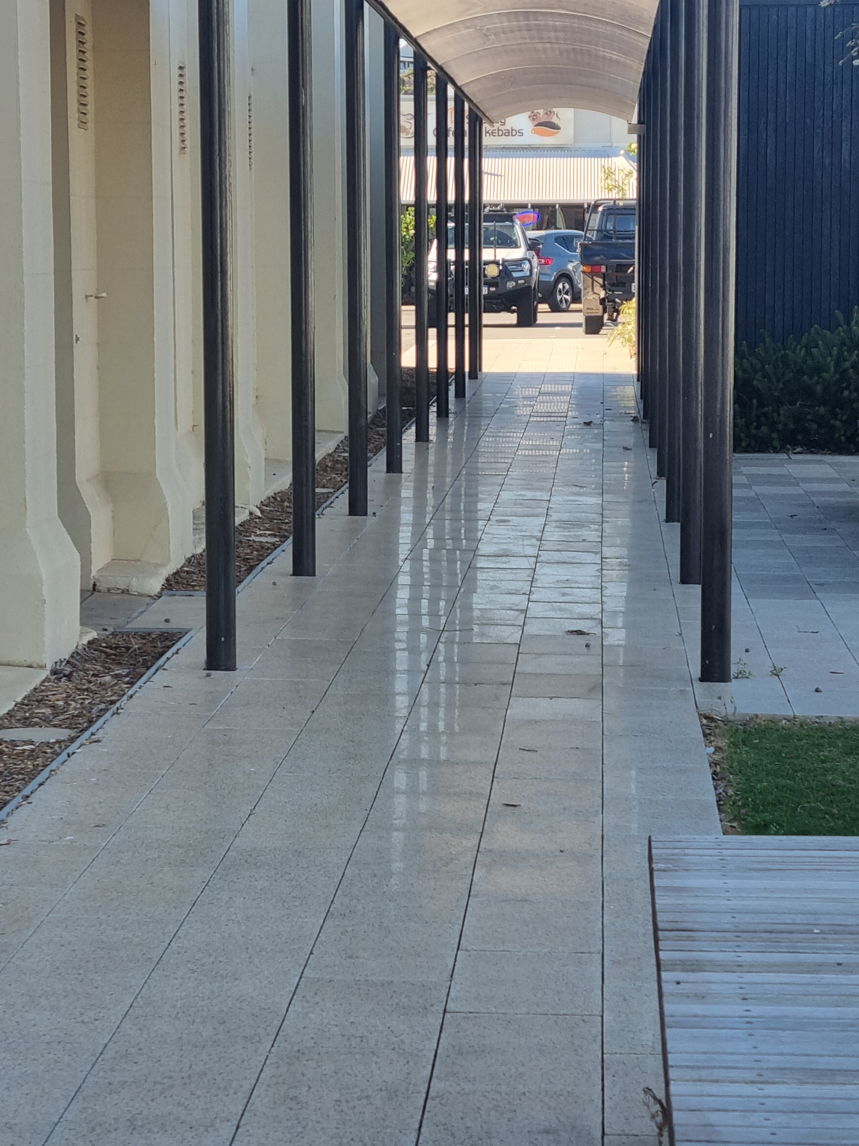
side entrance to toilets

COMMON AREAS

Parks and gardens
- The following parks and gardens amenities are available
- Accessible toilets
- Accessible toilets are signed at regular intervals
- Seats are provided at regular intervals
- Accessible drinking fountains
- Edge protection is provided
- Edge protection is a contrasting colour to the deck
  - Parks and Gardens Access/Entry Image(s)
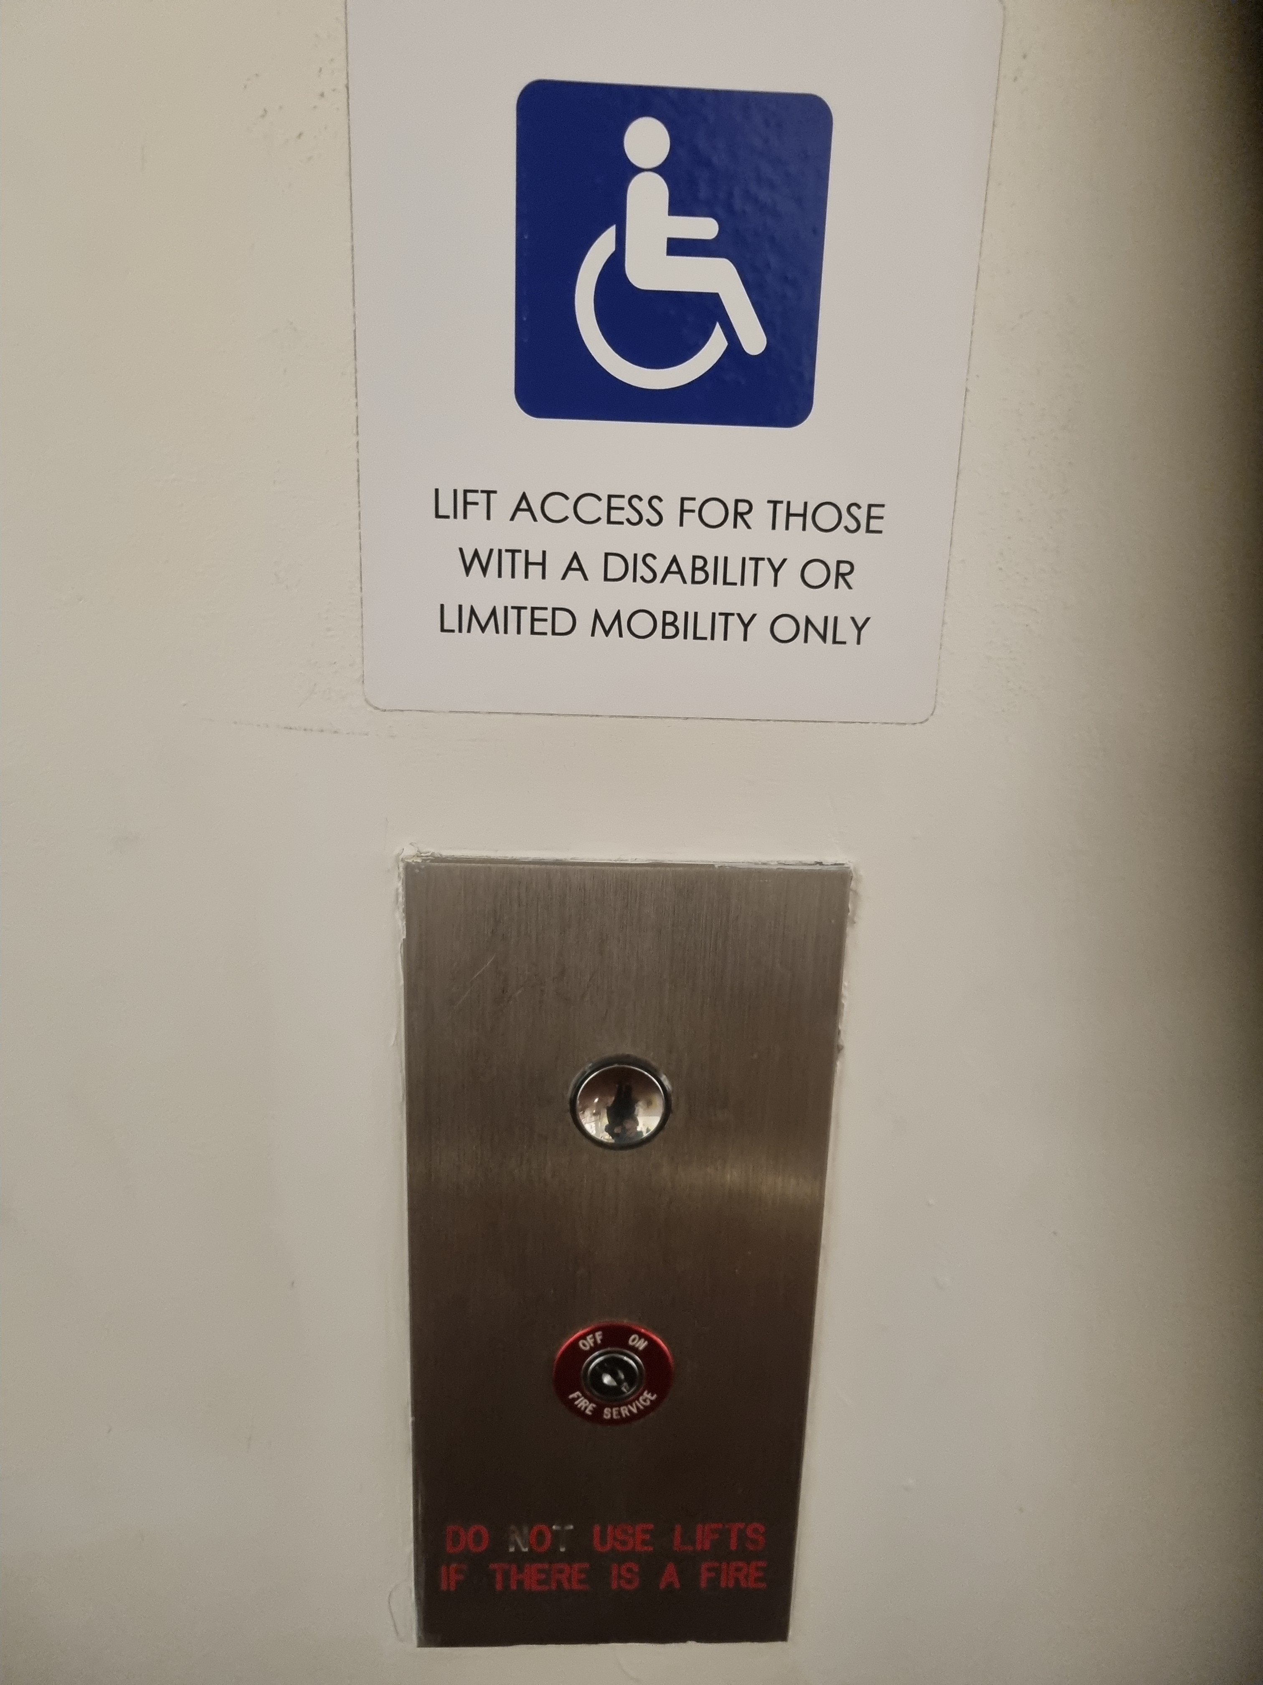
20240426_094439
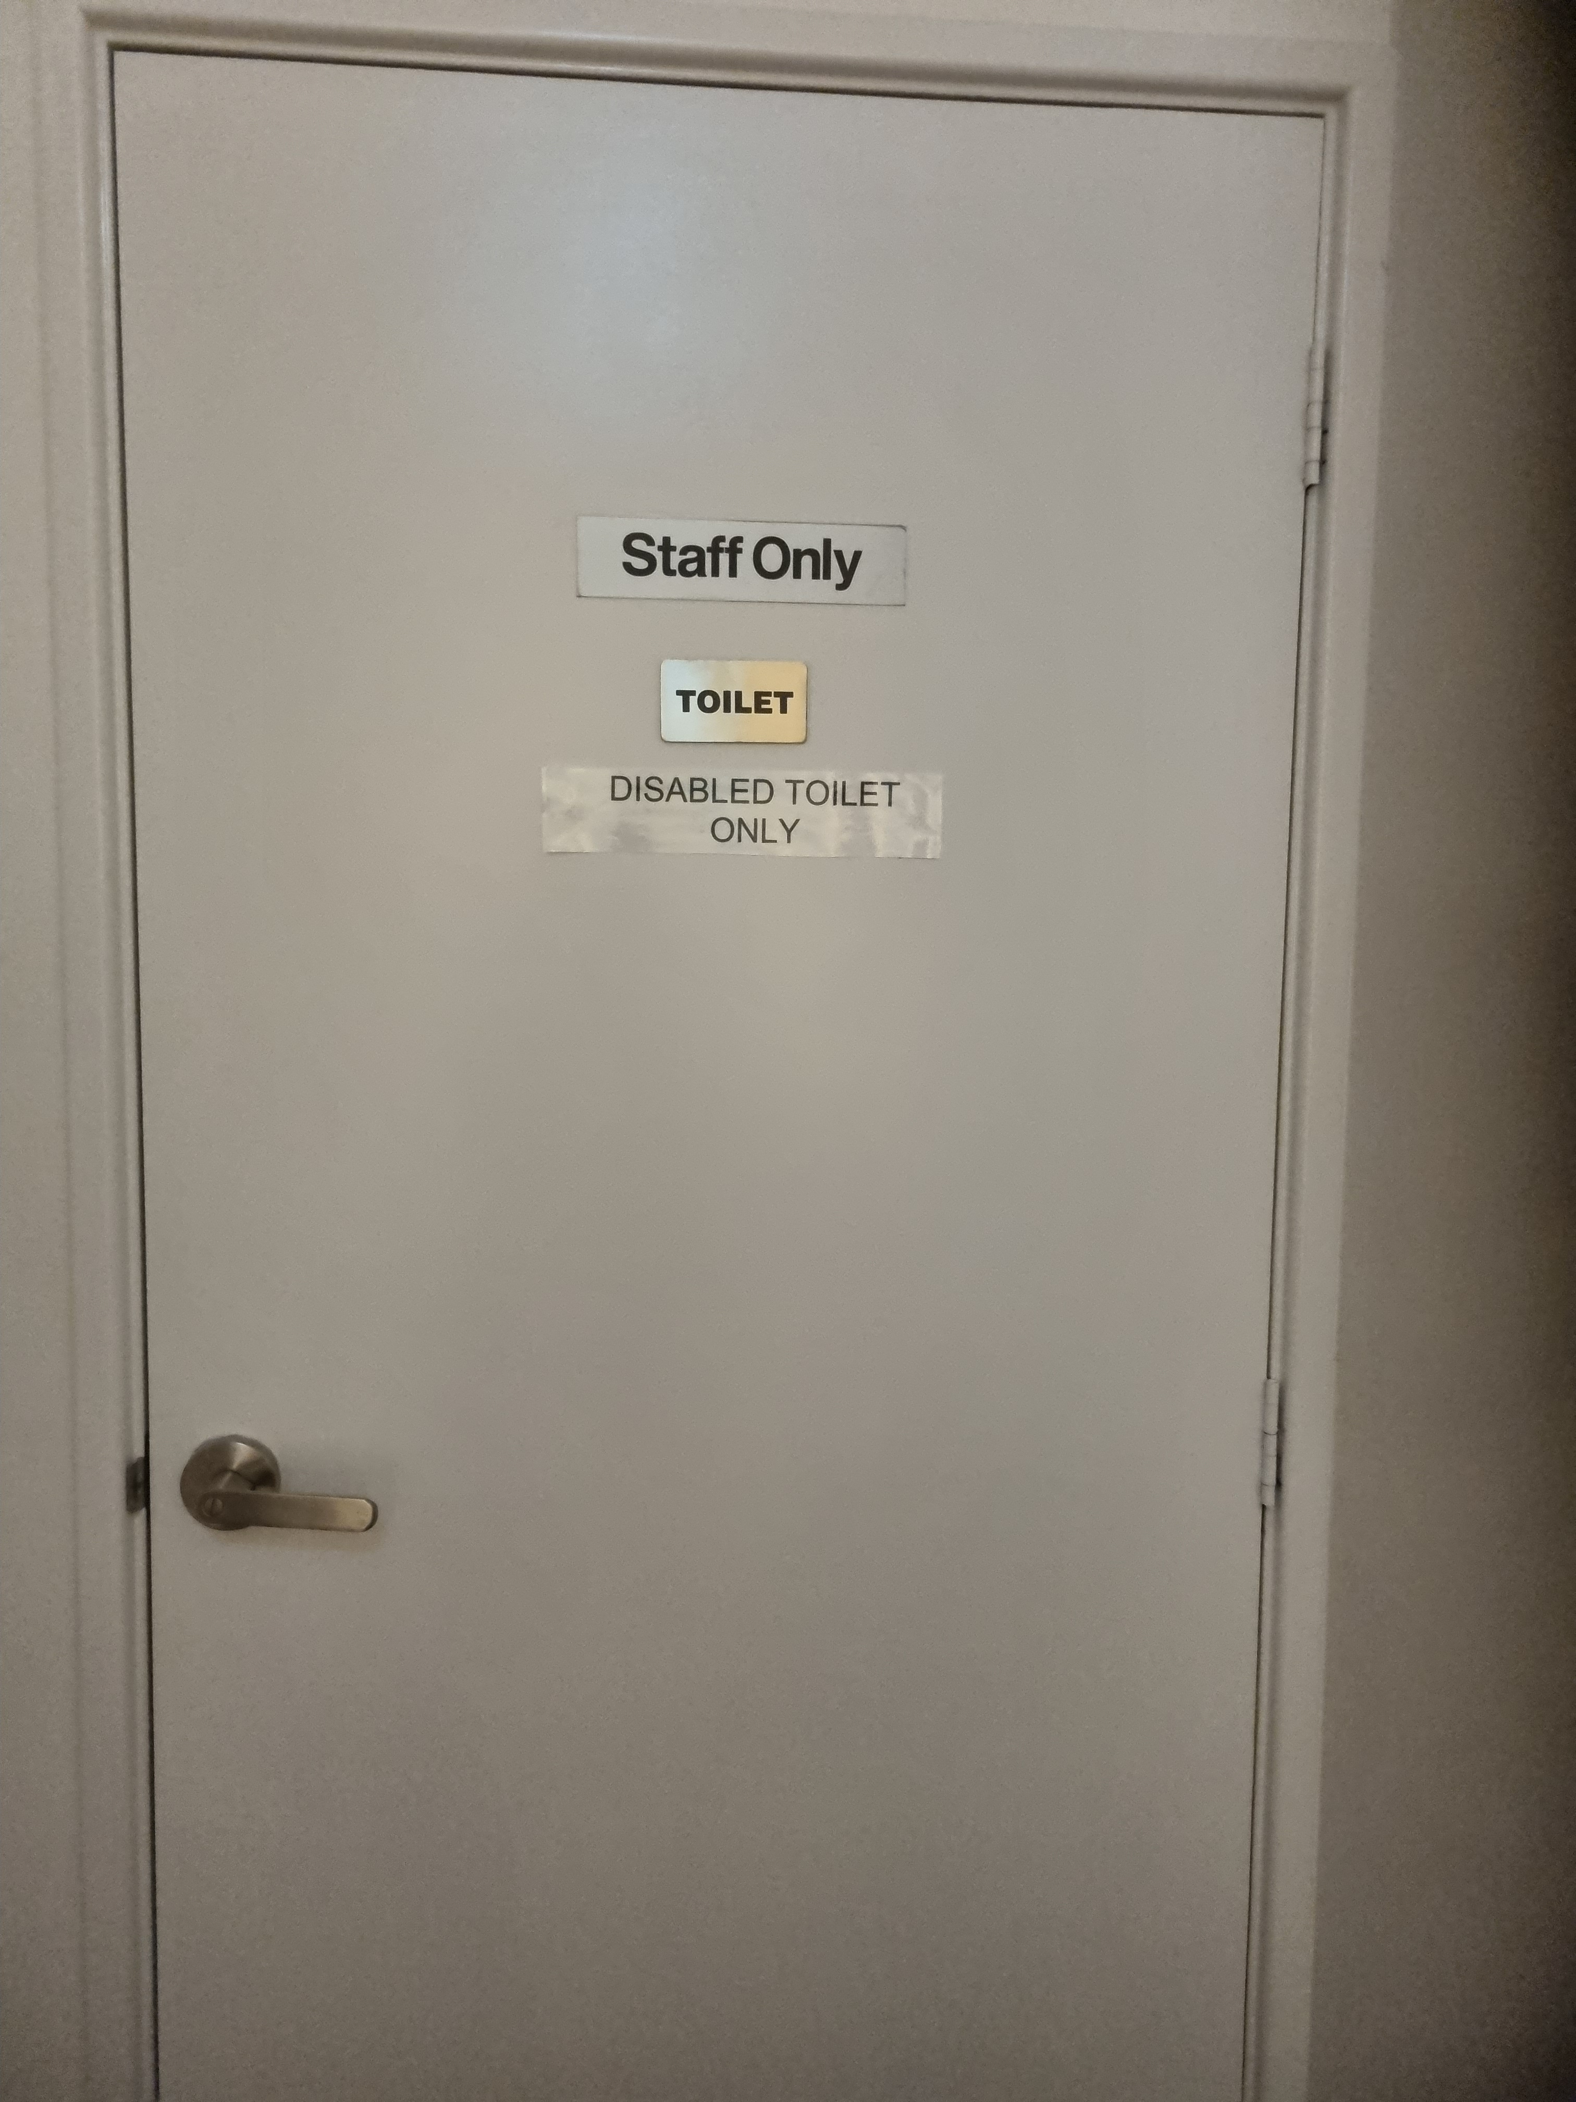
disabled toilet inside building
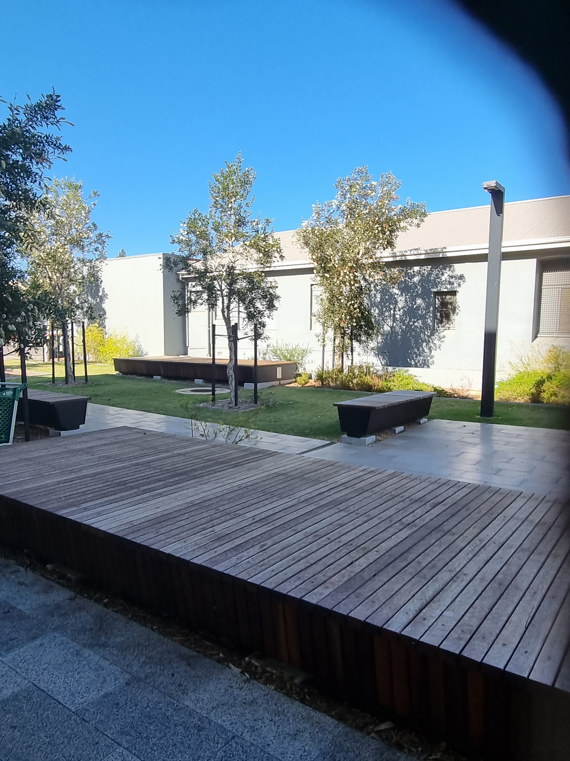
park area

Report Disclaimer
Please note that this business report, provided as a result of the use of the diagnostic assessment, is for information purposes only.
Australian Tourism Industry Council (ATIC) cannot guarantee the accuracy of respondent’s answers, or that they are fully representative of your business. Therefore, ATIC does not warrant or guarantee any particular outcome in respect of your businesses self-assessment.
This report is intended as guidance only for your business and should not be relied on for future marketing considerations. ATIC recommends that you seek your own independent advice as well as the results from the diagnostic.
Links to external web sites are inserted for convenience and do not constitute endorsement of material at those sites, or any associated organisation, product or service.
ATIC does not:
- Assume any legal liability for the accuracy, completeness, or usefulness of any information from this report or any links provided; or
- Accept responsibility for any loss associated directly or indirectly from the use of this report

